TFO
Report Design Using Microsoft Access

LAB OBJECTIVES
- Understand the Report Wizard.
  - Choose Table or Query.
  - Explain Grouping.
  - Perform Sorting.
  - Choose Layout.
  - Modify Properties.
  - Create Totals.
- Apply Report Design Guidelines.
- Use the Report Wizard to Create a Report.

Why Reports?
In Labs 9 and 10 we used queries to report information from our database. What does a Microsoft Access report do that a query cannot? For one thing, a report can provide formatting options that a query cannot. For instance, with a report you can put heading information in one part of the report and detail in another part of the report. You can also use different font formatting to set bold, italic, font face, and font size for different parts of the reports.

A report also allows you to display both detail and sub-totals or totals on your data. For example, we could report the order detail lines of each order with a total for each order. This would be very difficult to do with a query. Finally, reports have built in functionality to handle paging, including page headers and footers and section headers and footers.

In fact, queries and reports often work hand-in-hand. It is common for an Access developer to first design and save a query that pulls and calculates needed information from multiple tables. Then the developer creates a report based on that query. Of course, you can also base a report on a simple table, which is what we will do first.

Creating a Report With the Access Report Wizard
Microsoft Access provides a wizard that leads you through report creation and does a lot of the work for you. You don't have to use the wizard, but many Access developers find it faster in the long run to let the wizard create the base report and then manually modify it. That is what we will do. Do the following:

- If you have not already done so, launch Microsoft Access and the special version of the Northwind database that works with these labs.
- In the menu at the top of the window, click Create.
- Click on the Report Wizard icon in the toolbar.
- You will see the wizard dialog box shown here. Let's assume we want to report certain fields from the Employees table. From the Tables/Queries dropdown box, select Table: Employees.
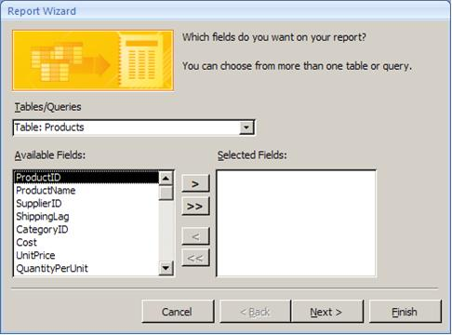
From this dialog box, you can select which fields of the Employees table you want in the report. Use the buttons in the middle of the screen to move the fields you want from Available Fields to Selected Fields.

- For our report, place into Selected Fields the following: LastName, FirstName, Title, Dept. When those four fields are displayed in that order in the Selected Fields box, click Next.
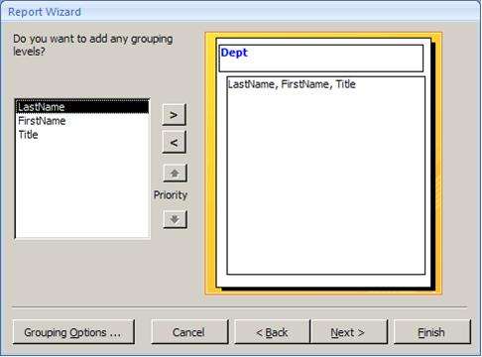
On the next screen, you can choose how you want records grouped on the report. Grouping has to do both with sorting the records and with formatting them on the report. Groupings can be given their own headings and footers. The wizard has generally suggests something based on the nature of the data underlying your report. In this case it has suggested grouping by Dept.

- But let's suppose we don't want the employees grouped by Dept. Click the button. This will move Dept from the grouping area on the right back into the field list.
- Click Next.
After dealing with grouping the next screen asks about sorting. Sorting just arranges the records within the groups.
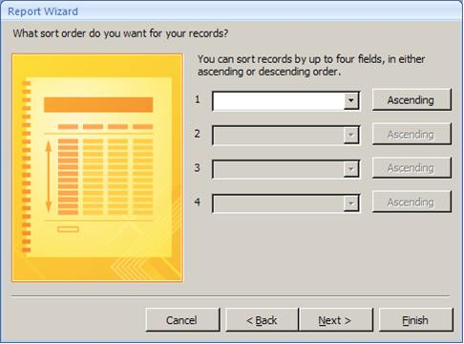
- We want to sort by LastName. So in the dropdown box beside 1, select LastName.
- The button that says Ascending indicates that the report will sort records by LastName in Ascending order. If you want to sort in descending order, click the button, and it will then say Descending. In our case do not click it.

With the dropdowns beside 2, 3, and 4 you can add additional sorting levels. For instance, we could sort by Firstname within LastName. But that is not relevant with our data.

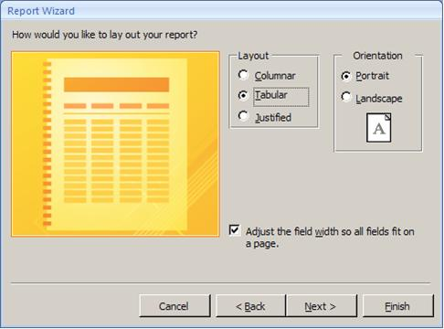
- Click Next.

The next screen lets you choose the layout and orientation of your report. You can click on Columnar, Tabular, and Justified and watch the changes in the thumbnail diagram to see how each works.

- Most reports are set up as Tabular. Click Tabular. Click Portrait.
- Click Next.

On the next screen, you can select a report style. As with the prior screen, you can click on any styles and see the thumbnail presentation of it.
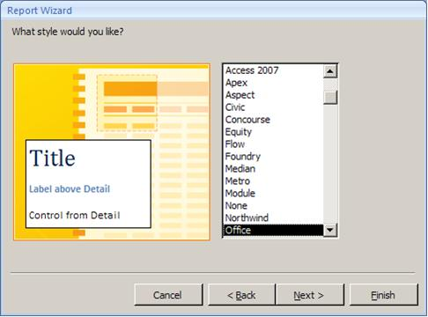
- Highlight the Urban style and then click Next.

On the last screen, you can enter a title for the report. This title will be both the name the report is saved with and the title displayed at the top of the report. However, if you wish you can change them to be two different titles later.

- Name the report "Employees Names and Titles." Click Finish. The report will be displayed as shown below.

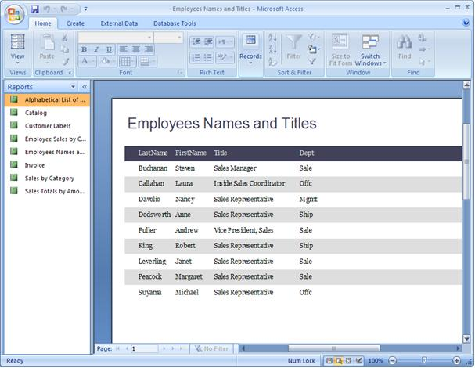

Report Design View
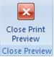
Once a report has been created, you can modify it with the Design View. Do the following.

- Click the Close Print Preview icon in the toolbar.
- You will see the design of the report as shown below. If the screen does not look like that, click the design view icon in the lower-right corner of the screen.

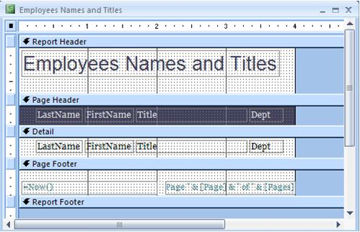

First, notice the objects that say "LastName," "FirstName," "Title," and "Dept" in two places on the report. The boxes under the Page Header are labels that display the set text "LastName," "FirstName," etc. Labels display constant text to help the user identify the data. The boxes in the Detail band are text boxes that display the actual data. Also notice the blue bands that separate the report into sections. Here is what each band does:

Report Header | Prints once at the top of the report
Page Header | Prints at the top of each page of the report. On page 1, it prints just under the Report Header.
Detail Band | Prints over and over for each row of data.
Page Footer | Prints at the bottom of each page of the report.
Report Footer | Prints once at the bottom of the report. It always prints on the last page following the last line of detail and below the Page Footer.

For instance, even if we had several pages of employees the title "Employees Names and Titles" would print only once at the very top of the report. However, the headings that say "LastName," "FirstName," etc. would print on every page. The Detail band will be printed for each line of text. The Page Footer would print at the bottom of every page. This report has no Report Footer.

- Use design view icon and the print preview icon in the lower-right corner of the screen to go back and forth between the two and see how the various bands are implemented.
Properties
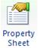
- Click the design view icon in the lower-right corner.
- Click the Property Sheet icon in the toolbar to display the Property Sheet.
- From the dropdown list at the top of the Property Sheet, select Report. You will see the report properties as shown here.

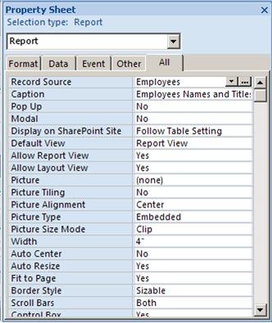
The Properties dialog contains various settings for the report. Record Source is the table or query that the report is based on. Caption is displayed at the top of the window when the report is in print preview mode. You can scroll through the list to see the other properties.

Note
There are five tabs at the top of the Properties dialog. The All tab contains all properties. The other four each contain a subset of the properties.

Not only does the report as a whole have properties. Every object on the report has properties, including each band, each text object, and each data object.

- With the Properties dialog still open, click on the LastName text box in the Detail band. The Properties dialog will now show properties for this text box. For instance, Control Source is the field in the table where this text box gets its data.
- With the Properties dialog still open, click on LastName label in the Page Header band. Notice that you can set back color (background), fore color (font color), font name, and more.
- With the Properties dialog still open, click on the blue Detail band itself. There are even properties for the bands

Editing Labels
The field names LastName and FirstName are in the Page Header band. It would look better to human readers of the report if they read "Last Name" and "First Name."
- Click on the LastName label in the Page Header band. One click will select the label as shown here.
- Now click again right between Last and Name. You should get an Insert cursor as shown here. If this doesn't work, click away from the label and then try it again.
- Press the space bar to add a space between Last and Name.
- Repeat the process for FirstName.

Note
Another way to edit a label is to view the properties and edit the label's Caption property.

Reducing Space in a Band
The report wizard includes extra space between each detail line. For a small report like this one, that is fine. For a report of many pages, it is useful to compress some of that space. Let's do that.
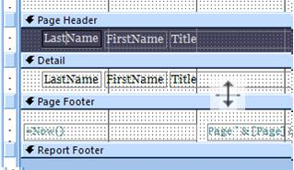
- Position the mouse at the top of the Page Footer band (just below the Detail band). The mouse cursor should change to what is shown here.
- Hold down the left mouse button and drag the mouse toward the top of the Detail band. This will make the Detail band vertically smaller, reducing the space between each line.

Moving and Sizing Objects
The Page Footer for this report has three elements. The text box on the left will display the current date and time when the report is run. The text box on the left contains special coding to display the current page number. Above both is a line. Let's resize each of these elements so that they all fit within the four inches of the rest of the report.

- Click in the middle of the =Now() text box on the left to select it. You will notice the little boxes on each corner and side of the text box as shown here. These are called sizing handles and are used to resize the text box.
- Position the mouse over the button at the right end of the text box. The mouse cursor should change to a two-headed arrow.
- Hold down the left mouse button and drag the mouse to the left to make the text box horizontally smaller. Drag it until the text box is a little less than two inches wide.
- Now click on the Page text box on the right to select it. Position the mouse on the top line of the box anywhere other than on one of the buttons. The mouse cursor should change to a four-headed arrow as shown in the diagram here. When you see this, you can move the text box.

- Hold down on the left mouse button and drag to the left to position the text box just to the right the other text box.
- Then resize the text box on the right so that its right edge does not extend beyond the four-inch mark on the report.

Aligning Objects
After moving or resizing objects you may want to align them to make them look better.

- Select two or more objects. You can do that either by holding down the shift key while clicking on multiple objects or dragging a marquee around multiple objects.
- Click on Arrange in the menu at the top of the screen.
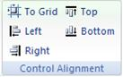
- Click on one of the Control Alignment icons.
- Access always moves the selected objects to the rightmost or leftmost or topmost or bottommost it can (i.e. if you click on Left, it will move all objects other than the leftmost object to be aligned with that object).
Your redesigned report should now look like this.

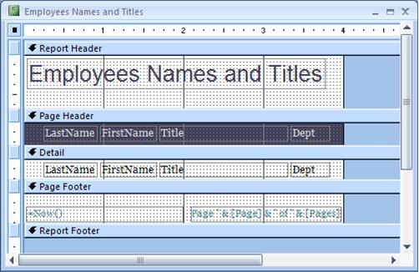

- Click the Print Preview icon to view the results.
- Close the report and save your changes.

Creating a Report Based on a Query

- In the menu at the top of the window, click Create.
- Click on the Query Design icon in the toolbar.
- From the Show Table dialog, Add both the Products and Suppliers tables.
- Add the following fields to the design grid: ProductName, CompanyName, UnitsInStock, UnitsOnOrder.
- Enter criteria so that the query will include any product with either more than 0 in stock or 0 on order. Your design grid should look like what is shown here.

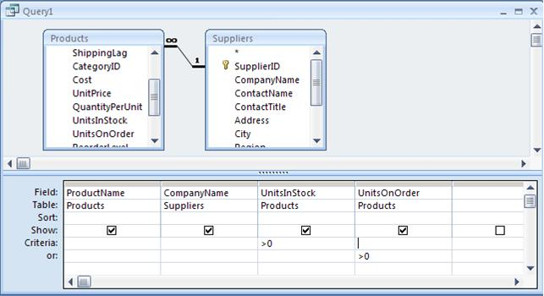

- Save the query with the name "Product Inventory". Close the query.
- In the menu at the top of the window, click Create.
- Click on the Report Wizard icon in the toolbar.
- On the first screen of the wizard, scroll down in the Tables/Queries dropdown box below the tables and select Query: Product Inventory.
- Move all the fields of this query to the Selected Fields window and then click Next.
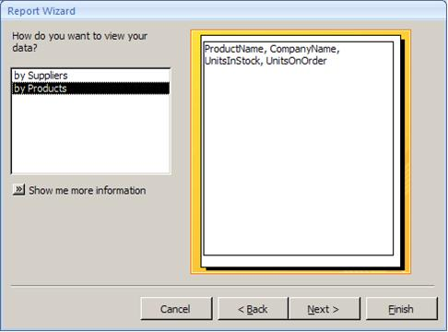
- On the next screen of the wizard, highlight "by Suppliers" to group the report by the CompanyName of the supplier. The screen will look like what is shown here.
- On the next screen do not add any other grouping levels.
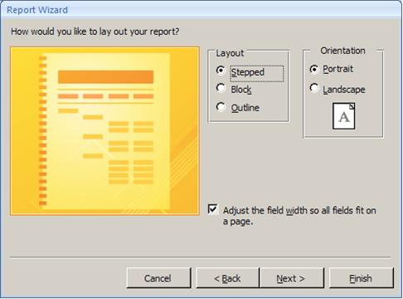
- On the next screen, sort the report by ProductName. The products will be grouped by supplier and sorted within each supplier by ProductName.
- By using grouping, your layout options will be a little different than what you saw before. Choose the "Stepped" layout.
- On the next screen, choose the Apex style.
- On the final screen, name the report "Product Inventory."

The completed report will appear as shown below.

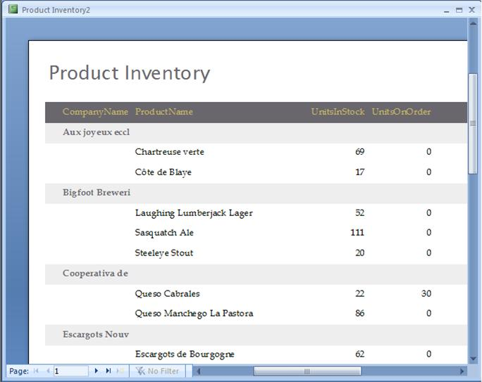

- Click the Design View icon in the lower-right of the screen.
You will notice that there is a CompanyName Header band that holds the label and text box for CompanyName and also the labels and lines that form the heading for each supplier's detail section. This is how the company name of each supplier and the headings are repeated throughout the report. Each time the supplier company name changes in the data, this CompanyName Header band is repeated.

- Change the label for "CompanyName" to "Company Name." Change the label for "ProductName" to "Product Name." Change the label for "UnistsInStock" to "Units In Stock." Change the label for "UnitsOnOrder" to "Units on Order." This is review from the first report exercise. See the instructions there if you need help.

Adding Subtotals
It would be nice to have subtotals for Units In Stock and Units On Order for each supplier. But these subtotals would need to go into a footer band for the supplier CompanyName. This does not currently exist, but we can create it.
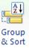
- Click on Design in the menu.
- Click on the Group & Sort icon in the toolbar. The Group, Sort, and Total box will appear at the bottom of the screen.
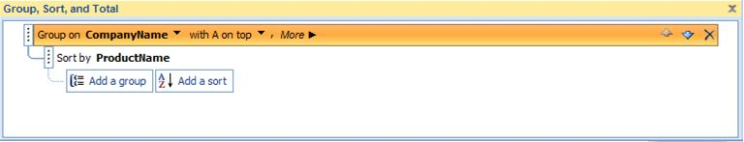
- In the "Group on CompanyName" band, click on More.
- Click the dropdown beside where it says "without a footer section" and change it to "with a footer section."
- Close the Group, Sort, and Total box. Your report design should change to what is shown here. Notice the new CompanyName Footer.
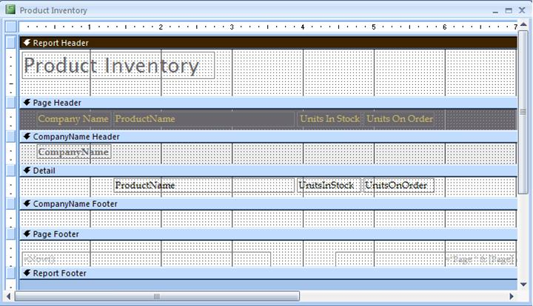

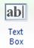
- To add the subtotals we need to add a text box to hold the subtotals. Click the text box icon in the toolbar. Then click anywhere into the CompanyName Footer. This will add a new text box. We will worry about aligning it properly later. The CompanyName Footer band will now look something like what is shown here.

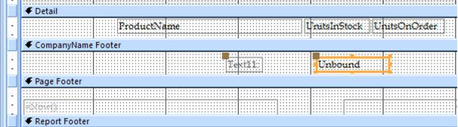

You may recall from the QBE lab that the SQL aggregate for total is Sum. We can use that here - another reason why SQL is so handy to learn.

- Your new text box should already be selected as shown above. If it isn't, click on it to select it. Then view the Property Sheet for the text box.
- In the Control Source property, type: =Sum(UnitsInStock)
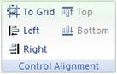
- Now we need to align the subtotal with the detail text box above. If the new text box is not already selected, select it. Hold down the Shift key and click on the UnitsInStock text box in the Detail band.
- With both text boxes selected, click on Arrange in the menu and then, depending on where you placed the new textbox, click on the Left or Right icon in the Control Alignment section of the toolbar. See the tip below to determine whether to click on Left or Right.
Tip
Here is how Access aligns multiple objects. It always moves the selected objects to the rightmost or leftmost it can. In other words, in the screen shot on the previous page with the new text box (marked Unbound) and the UnitsInStock text box selected, clicking Left would move the less left Unbound text box to just underneath the more left UnitsInStock text box. Clicking Right would move the less right UnitsInStock text box to just above the more right Unbound text box.
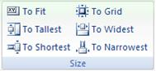
- We should also size our new subtotal to the same size as the UnitsInStock textbox. With them both still selected click the To Narrowest icon in the Size section of the toolbar.
- Our subtotal should be labeled properly. So change the label that in the screen shot above says "Text11" (yours will probably be a different random label) to say "Sub Total."
- Now add a second text box, make it be a subtotal of UnitsOnOrder and align it properly. You can delete the label that came with it by clicking on the label and then pressing the Del key on your keyboard. If you delete the wrong thing, you can Undo it. Your CompanyName Footer should now look like what is shown here.

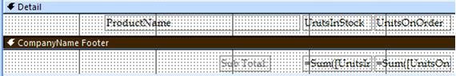

- Click the print preview icon in the lower-right corner to look at your subtotals.
- Click the design view icon in the lower-right corner.

Adding Grand Totals
Adding a grand total isn't any harder than adding a sub total. But first we need a place to put the grand total. It needs to go in the Report Footer band because it comes last in the report. But our report currently doesn't have any Report Footer band. We can add it.
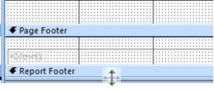
- Position the mouse at the bottom of the blue bar that says Report Footer. The mouse cursor will change to what is shown here.
- Hold down on the left mouse button and drag down until the Report Footer band is about the size of the CompanyName Footer band.
- Follow the procedure discussed above for subtotals to add the grand totals. You will still use =Sum(UnitsInStock) and =Sum(UnitsOnOrder). But they will be grand totals because of their position in the Report Footer band. Set the label to say Grand Total. Be sure to properly align your text boxes and labels.
- Click the print preview icon in the lower-right corner of the screen. Use the navigation buttons at the bottom of the report to move from page to page. Notice that the Report Header is shown only on the first page. Notice that the Report Footer is shown only on the last page. However, the Report Footer is not the very last thing on the report. The Page Footer for the last page displays at the bottom.
- Close the report and save your changes.

Report Design Guidelines
As you can see, creating a report in Access involves a few relatively simple steps. The more difficult and more important task is designing the report so that it meets the needs of the users. User needs can be determined through interviewing. It is also useful to create a prototype of a report on paper or with a CASE tool prior to putting in the work of actually developing the report. Because Access reports can be created so quickly, Access is, in fact, a pretty good prototyping tool for other programming environments.
There are also some generally accepted guidelines for report design. The following guidelines are adapted from your textbook.

- Every report should have a title.
- Every report should be date and time-stamped so the user knows how current the information is.
- Every piece of information on the report should be labeled. Labels should be short and descriptive. Avoid abbreviations if possible. All abbreviations should be explained in a legend except for extremely common abbreviations, such as ID.
- Normally columns of numbers should be right-justified and columns of text should be left-justified. Alignment should be tested with users for preferences.
- Data, such a telephone numbers, social security numbers, and dates, should be formatted to match users' norms.
- Information should be balanced on the report - not too crowded and not too spread out.
- Frequently, rows represent groups of data. Those groups should be logically grouped on the report.
- Page headers and/or footers should appear on every page and include the report title, date and time, and page numbers.
- The end of the report should be indicated to ensure that users have the entire report. This can be done with *** END OF REPORT *** in the report footer. This can also be accomplished by specifying page numbers as: x of y.

Key Terms

Columnar Layout
Control Source
Detail Band
Grouping
Justified Layout
Label
Layout
Orientation
Page Footer
Page Header
Print Preview View
Properties
Report Design View
Report Footer
Report Header
Report Style
Report Wizard
Sorting
Tabular Layout
Text box

Exercises

Your instructor will specify how you are to prepare and submit the answers to the following exercises.

- Create a report based on the Quarterly Orders query that already exists in Northwind. Place all the fields of the query into the report. Group by Country and sort the records within country by Customer ID. Modify the wizard-created report in accordance with the Report Design Guidelines.
- One of the suppliers, Exotic Liquids, is having a sale. Create a query that lists the product IDs, names, quantity per unit, unit price, units in stock, and reorder level of all products purchased from that supplier. Save the query with the name Exotic Products. Then create a report based on this query. Add totals for Units in stock at the bottom of the report. Revise report in accordance with the Report Design Guidelines.
- Using the report wizard, create a tabular report of the Employees table. Include in order from the left, the hire date, employee ID, first name, and last name. Sort the report ascending by last name within hire date (you can do this as part of the wizard or by the “Sorting and Grouping” option of the View menu. Change the title of the report (in the Page Header band) to “Employee Listing by Hire Date”. Revise report in accordance with the Report Design Guidelines.
- Create a report from the Customers Table that includes all the fields, is sorted by Company Name, and is in columnar layout. Revise report in accordance with the Report Design Guidelines.
- Create a query that lists from the Products table all Product Names that contain the words Cajun, Gumbo, or Hot. Next create a report using the “Create report by using wizard” option to show all the product names of this query. Do not use any type of grouping, but do sort upon the Product Name. Title your report “Hot Products”. Select the title label, bring up the Properties box, and change the title Font Name to Script and Font Size to 28. Revise report in accordance with the Report Design Guidelines.
- Create a query that lists from the Products and Category tables the Category Name and the average Unit Price. Next create a report using the “Create report by design view” option to show all the fields of this query. Do not use any type of grouping. Sort by Category Name. Title your report “Category Average Prices”. Set the title to Arial Black and the Font Size to 16. Revise report in accordance with the Report Design Guidelines.
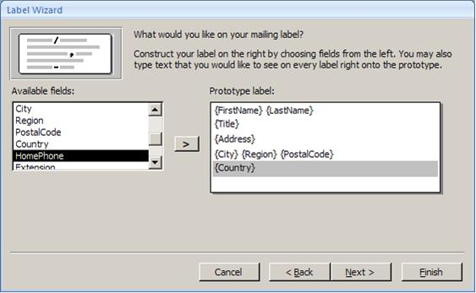
- Click the dropdown button at the top of the Database Window on the left side of your screen and select Table. Select the Employees table. Then click on Create in the menu and click the Labels icon. This will launch a Label Wizard for the Employees table. Select the default label type, font, and color. Build your label format using the format shown here. Remember to add spaces between the fields on the form. Sort the label by the by PostalCode, LastName, and FirstName. Finish the wizard and display the label (ignore any warnings about not enough space). Save the report.
- A Microsoft Access function for displaying part of a field is Left(). Inside the parentheses, include the field name followed by a comma and the number of characters you want to display. So, for instance, Left(lastname,3) would display the leftmost 3 characters of the Lastname field. Use this to create a query that lists the first letter of the company name of each customer along with the full company name, contact name, and phone number. Then create a report to serve as a phone directory for customers. Group by the first letter field and sort within each letter group by company name. Revise report in accordance with the Report Design Guidelines.
- You can calculate more than just aggregates on reports. You can take any formula you would use in a calculated column on a query and place it after an equal sign in the Control Source property of a text box. Edit the Product Inventory report created during the chapter. Add another text box to the Detail band that adds together UnitsInStock and UnitsOnOrder. Add a label for this text box in the CompanyName Header that identifies it as "Tot Units." Revise report in accordance with the Report Design Guidelines.

